SHOP THE PANTRY 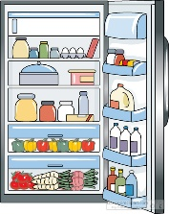
A successful pantry challenge begins with an inventory of the food you have on hand.

Refrigerator | Freezer | Pantry

Winter 2017 Pantry Challenge with www.AReinventedMom.com

